Chapter 16, Problem 49.

Find i_{o}(t) for t > 0 in the circuit in Fig. 16.72.

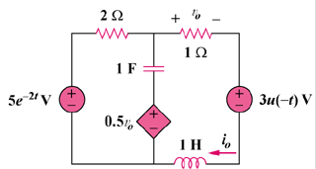

Figure 16.72
For Prob. 16.49.

